Type the Title Here
The Style is Named Title
Type the abstract here. The style is named Abstract. Type the abstract here. The style is named Abstract. Type the abstract here. The style is named Abstract. Type the abstract here. The style is named Abstract.
Word count: ###

Type the text here. The style is named Normal for regular paragraphs. The Normal style is set up as Times New Roman, 12 point with 1.5 line spacing. These are the specifications suggested for manuscript submission. This should be an introductory paragraph(s) and it should not have a heading. It should start on a new page.

I. First Level Heading – The Style is Named Heading 1
Type the text here. The style is named Normal for regular paragraphs. Type the text here. The style is named Normal for regular paragraphs. Type the text here. The style is named Normal for regular paragraphs.

A. Second Level Heading – The Style is Named Heading 2
Type the text here. The style is named Normal for regular paragraphs. Type the text here. Heading levels are largely up to you: you may be willing to use more than one but should not feel obliged to do so.
(1) $Equation – The style is named Equation$,
where … The style is named Normal No Indent when you want a non-indented paragraph, especially after an equation. Place an extra return after the equation for spacing. Keep the following in mind: equations should ideally use the word equation widget (InsertEquation). Also, remember to number equations in parentheses on the left.
(2) $Equation – The style named Equation$.

The style is named Normal after an equation when you want an indented paragraph. Place an extra return after the equation for spacing.

Third Level Heading — This is an example of a third level heading. The style is named Heading 3. An em dash should separate the heading from the paragraph text. When applying this heading, additional formatting can be manually added if preferred, but it is not required. Italics will automatically be applied in production.

Fourth Level Heading: This is an example of a fourth level heading. The style is named Heading 4. A colon should separate the heading from the paragraph text. When applying this heading, additional formatting can be manually added if preferred, but it is not required. Bold will automatically be applied in production.

B. Footnotes
Insert footnotes as necessary using the Insert | Footnote menu item in Word 2003 or the References | Insert Footnote ribbon item in Word 2007. The footnote number in the text is formatted automatically. An area for the text for the footnote appears at the bottom of the page and is formatted automatically.

C. List Styles
Examples follow for bulleted and numbered lists.

- This is a bulleted list. Only one level is generally used.
- The style is named List Bullet.
- This is a bulleted list.

- This is a numbered list. Only one level is generally used.
- The style is named List Number.
- This is a numbered list.

D. References
A sample reference is shown below.
REFERENCES (this style is called Reference HeADING)
Last, First, and First A. Last. 2003. “Article Title” In Publication Name, ed. First Last. 335–405. City: Publisher. The style named is References.

II. Sample Figure
A sample figure is at the end of this document. At publication, your figure must fit within the width of one printed journal page (5 inches or 12.7 cm).
If you choose to place a figure indicator in the text in the approximate location where the figure should go as shown below, the style of this indicator is called Figure Placeholder. You may choose to place the figures themselves at the end of the document.
[Insert Figure 1 Here – The style is named Figure Placeholder]

III. Sample Table
See the sample table at the end of this document. Your table may take up the full page width (5 inches or 12.7 cm) and must have no more than 9 columns.
You may choose to place a table indicator in the text in the approximate location where the table should go as shown below. The style of this indicator is named Table Placeholder. You may choose to place the tables themselves at the end of the document.
[Insert Table 1 Here – The style is named Table Placeholder]
You may enter your figures on this page of the template. Your figures may take up the width of one printed journal page, which is 5 inches or 12.7 cm.

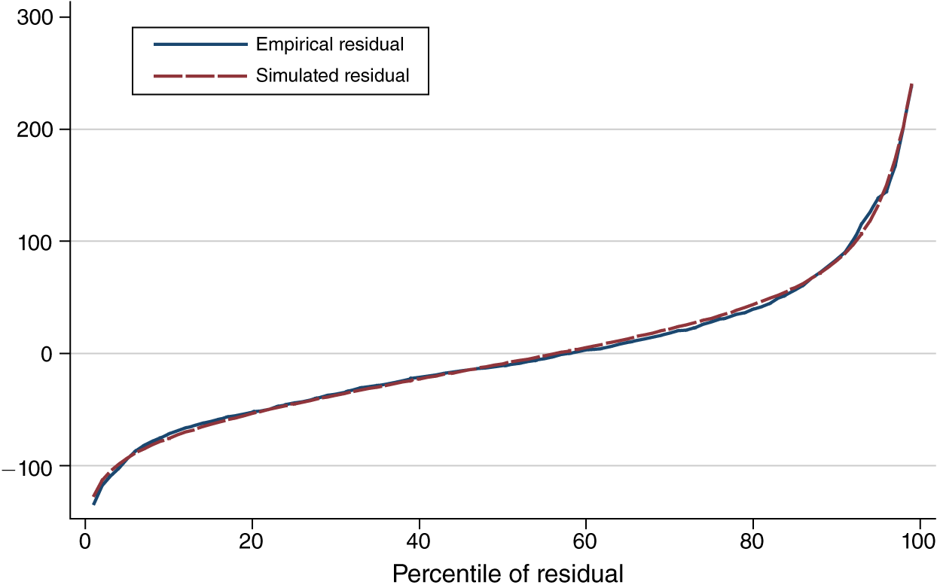
Figure 1. The Title of the Figure
The Style is named Figure Title
Notes: These are the notes applicable to the figure. The style is named Figure Notes.

You may choose to type your tables on this page of the template. Your tables may take up the width of one printed journal page, which is 5 inches or 12.7 cm. It should contain no more than 9 columns, which includes any row headings.

Table 1—The Title of the Table, The Style is Named Table Title
 | 1948–2007a | 1948–1972 | 1973–1994 | 1995–2007
Panel A. The style is named Table Text
Tangible | 11.4* | 11.2 | 12.3 | 10.4
Intangible | 8.6 | 5.9 | 9.2 | 12.8
Panel B. Share of capital input
Tangible | 76.2 | 82.6** | 74.8 | 66.1
Intangible | 23.8 | 17.4 | 25.2*** | 33.9
Notes: These are the notes applicable to the table. The style is Tables Notes.
Source: Author calculations. These are more table notes. The style is Table Notes.
a Applicable to the whole period. The style is named Table Footnote.
*** Significant at the 1 percent level. The style is Table Notes.
** Significant at the 5 percent level.
* Significant at the 10 percent level.

Type the footnote here. It is automatically formatted to the correct style.

